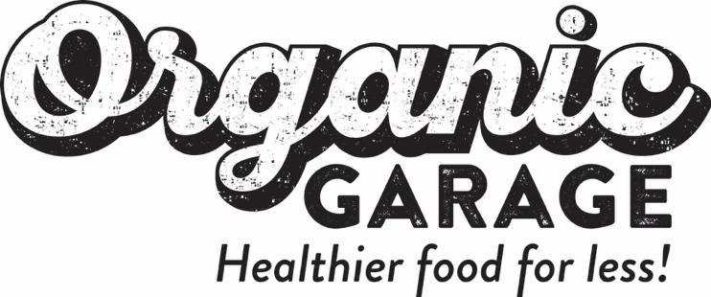

ORGANIC GARAGE Files FINAL Base Shelf Prospectus
AND ANNOUNCES stock OPTION GRANT

October 14, 2021, Toronto, Canada: Organic Garage Ltd. (TSXV: OG) (FRA: 9CW1) (OTCQB: OGGFF), one of Canada’s leading independent grocers, is pleased to announce that it has filed, and received a receipt for, a final short form base shelf prospectus (the “Shelf Prospectus”) with the securities commissions in the provinces of Ontario, British Columbia, Alberta, Manitoba and Saskatchewan.

The Company has filed this Shelf Prospectus to maintain financial flexibility and efficient access to Canadian capital markets to pursue its growth initiatives but has no immediate intentions to undertake an offering.

The Shelf Prospectus will allow the Company to offer and issue up to CAD $10 million (initially filed and disclosed as $15 million) of common shares, warrants, subscription receipts, units, or any combination of the foregoing (collectively, the "Securities") during the 25-month period that the Shelf Prospectus is effective. The Securities may be offered separately or together, in amounts, at prices and on terms to be determined based on market conditions at the time of sale. If any Securities are offered under the Shelf Prospectus, the terms of any such Securities and the intended use of net proceeds would be established at the time of the offering and would be described in a prospectus supplement to be filed with the applicable Canadian securities regulatory authorities at the such time.

A copy of the Shelf Prospectus is available on SEDAR (www.sedar.com).

Stock Option Grant

The Company also announces a grant of stock options (the “Options”), in accordance with the terms and conditions of the Company’s 10% rolling Stock Option Plan, to be granted on October 15, 2021 to certain officers, directors, employees and consultants of the Company, to purchase an aggregate of 1,050,000 common shares of the Company.

The Options will be exercisable for a period of 5 years from the date of grant at a price per share equal to the closing price of the common shares of the Company as at the date hereof, and will vest as to 25% on each of the date of grant and thereafter the Three-month, Six-month and, Nine-Month anniversaries of the date of grant.

Subject to acceptance by the TSX Venture Exchange, the grant of the Options will result in a total 5,735,000 options outstanding.

This press release does not constitute an offer to sell or the solicitation of an offer to buy Securities, nor will there be any sale of the Securities in any jurisdiction in which such offer, solicitation or sale would be unlawful prior to the registration or qualification under securities laws of any such jurisdiction.

The Securities have not been registered under the U.S. Securities Act of 1933, as amended, and may not be offered or sold in the United States absent registration or an applicable exemption from the registration requirements. This news release shall not constitute an offer to sell or the solicitation of an offer to buy nor shall there be any sale of the Securities in any State or jurisdiction in which such offer, solicitation or sale would be unlawful.

About Organic Garage Ltd.

Organic Garage (TSXV: OG) (FRA: 9CW1) is one of Canada’s leading independent organic grocers and is committed to offering its customers a wide selection of healthy and natural products at everyday affordable prices. The Company’s stores are in prime retail locations designed to give customers an inclusive, unique and value-focused grocery shopping experience. Founded in 2005 by a fourth-generation grocer, Organic Garage is headquartered in Toronto. The Company is focused on continuing to expand its retail footprint within the Greater Toronto Area. For more information please visit the Organic Garage website at www.organicgarage.com
For further information please contact:
Bill Mitoulas
T: (416) 479-9547
E: investor_relations@organicgarage.com
W: www.organicgarage.com

Neither TSX Venture Exchange nor its Regulation Services Provider (as that term is defined in policies of the TSX Venture Exchange) accepts responsibility for the adequacy or accuracy of this release.

Cautionary Note Regarding Forward-looking Statements
This news release contains certain forward-looking statements and forward-looking information (collectively referred to herein as "forward-looking statements") within the meaning of applicable Canadian securities laws. All statements other than statements of present or historical fact are forward-looking statements. Forward-looking statements are often, but not always, identified by the use of words such as "anticipate", "achieve", "could", "believe", "plan", "intend", "objective", "continuous", "ongoing", "estimate", "outlook", "expect", "may", "will", "project", "should" or similar words, including negatives thereof, suggesting future outcomes.
Forward looking statements are subject to both known and unknown risks, uncertainties and other factors, many of which are beyond the control of Organic Garage, that may cause the actual results, level of activity, performance or achievements of Organic Garage to be materially different from those expressed or implied by such forward looking statements. The Company is making forward-looking statements, including with respect to any future offering of Securities pursuant to the Prospectus and related matters; and the grant of the Options. Although Organic Garage has attempted to identify important factors that could cause actual results to differ materially from those contained in forward-looking statements, there may be other factors that cause results not to be as anticipated, estimated or intended.
Forward-looking statements are not a guarantee of future performance and involve a number of risks and uncertainties, some of which are described herein. Such forward-looking statements necessarily involve known and unknown risks and uncertainties, which may cause Organic Garage's actual performance and results to differ materially from any projections of future performance or results expressed or implied by such forward-looking statements. Any forward-looking statements are made as of the date hereof and, except as required by law, neither Organic Garage assumes no obligation to publicly update or revise such statements to reflect new information, subsequent or otherwise.

